Git Exercise - Command Reference

## 1. Check Git Installation

git --version

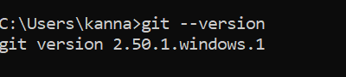

## 2. Configure Git Username

git config --global user.name "karnatisreejareddy9603"



## 3. Configure Git Email

git config --global user.email "sreejareddy9603@gmail.com"



## 4. Set Notepad++ as Default Editor

git config --global core.editor "C:/Program Files/Notepad++/notepad++.exe" -multiInst -notabbar -nosession -noPlugin

## 5. Verify Git Configuration

git config --list

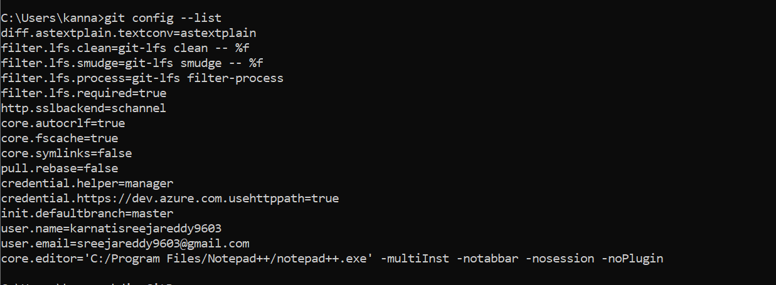

## 6. Create New Folder

mkdir GitDemo



## 7. Navigate to the Folder

cd GitDemo

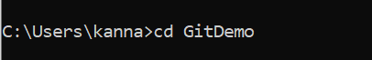

## 8. Initialize Git Repository

git init

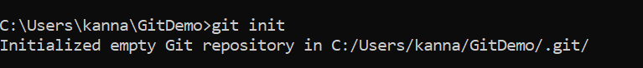

## 9. Create a File

echo Welcome to Git Demo > welcome.txt



## 10. Check File Created

dir  
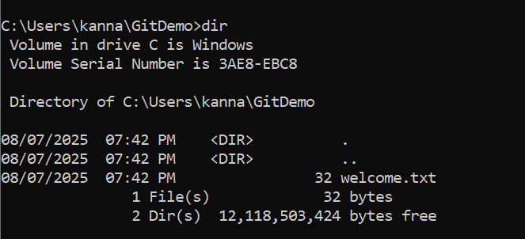

## 11. View File Content

type welcome.txt  
  
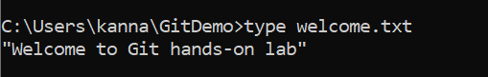

## 12. Check Git Status

git status

## 13. Add File to Staging

git add welcome.txt



## 14. Commit the File

git commit

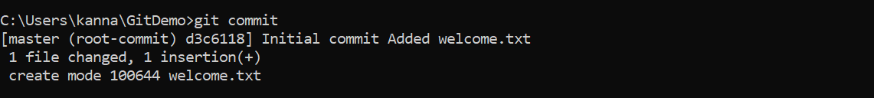

## 15. Create Repository on GitHub (Done via browser)

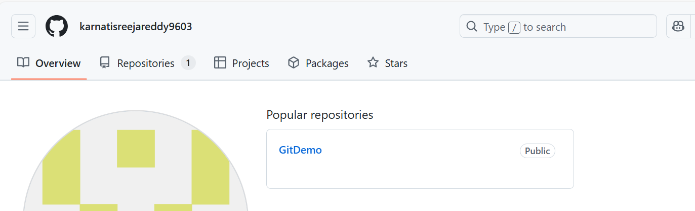

## 16. Add Remote Origin

git remote add origin https://github.com/karnatisreejareddy9603/GitDemo.git  
  


## 17. Push to GitHub

git push -u origin master

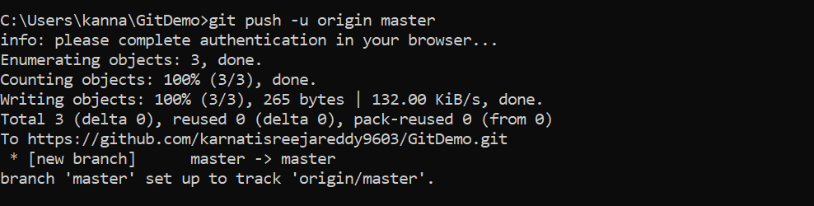

## Output

